1. What are the outputs if x = 1 and y = 1, and x = 1 and y = 0, respectively? A step function is used in each neuron. w1 = w2 = w4 = w6 = 1, w3 = -1.5, w5 = -2 and w7 = -0.5.

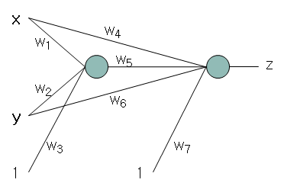

2. Set *w1, w2, w3, w4* so that the output is 1 only if at least one of inputs is 1s, where *f* is a step function.

 f

*x2*

*o*

*w1*

*w2*

*x1*

*x3*

*w3*

1

*w4*

3. Fill out the tables on the slides 4 ~ 7 in “9-3. Neural Networks-EBP-3.pptx” for the second iteration of the XOR neural network training.

4. Implement the error back propagation algorithm for the $y=x\left(1-x\right)$ neural network on slide 12 in “9-3. Neural Networks-EBP-3.pptx”. You may change the number of hidden nodes, iterations, learning rate. Submit the followings:

- the code

- the final values of weights

- draw a graph for the output of neural network for $x=0.00, 0.01, 0.02, 0.03, 0.04, …, 1$